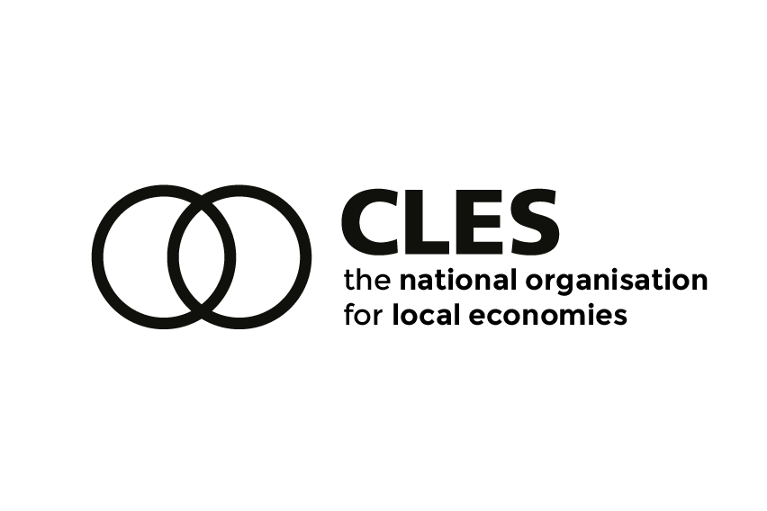
EMBARGOED UNTIL 0001 FRIDAY 24 JUNE 2022
From: Centre for Local Economic Strategies (CLES)
For media enquiries, please contact Helen Power, Policy and External Affairs Manager at CLES (07853 266 598 / helenpower@cles.org.uk).
Think tank: Welsh employee ownership could be “an inspiration to the rest of the UK and beyond”
The value of devolution in enabling local policy makers to deliver on local economic ambitions could be powerfully demonstrated by the Welsh government with a legislative commitment to increasing employee ownership, argues a new report from the think tank the Centre for Local Economic Strategies (CLES) .
Already committed to the foundational economy as a cornerstone of their economic strategy, focussing on employee ownership would enable the Welsh government to deliver a more inclusive, secure and sustainable economy, say the authors of the report.
The Welsh Programme for Government commitment to doubling the number of employee‑owned businesses – from 30 to 60 – is a welcome stepping stone but, CLES argue, too modest in its scale and ambition. Instead, the report Owning the workplace, securing the future lays out a plan to look far beyond that objective with a new law inspired by the former Italian industry minister Giovanni Marcora.
Introduced in Italy in the mid- 1980s to facilitate worker buyouts of enterprises at risk of closure, the “Marcora Law” enabled collaboration between the state, co-operative sector, business owners and workers, which resulted in the development of 796 “worker-recovered enterprises” in Italy between 1986 and 2001.
While the Marcora Law provides an inspiring frame of reference, the limited devolved powers to the Senedd means the approach cannot (currently) be replicated in Wales. Instead, the legislation set out in Own the workplace is a bespoke proposal designed to work for Wales.
Key provisions of the legislation recommended in the report include putting the objective of increasing the contribution of employee owned businesses to the Welsh economy onto a statutory footing. This would be supported by legislation to ensure that workers wanting to buy out all or part of a business facing closure or down-sizing would be able to access financial support and advice. The provisions are supported by recommended policy measures, including the development of a ring-fenced loan fund, to be administered by the Development Bank for Wales.
CLES’s Associate Director and co-author of the report, John Heneghan, says:
“Since the founding of the Rochdale Pioneers, the United Kingdom has been a forerunner of co-operative enterprise but there is much to be done if employee ownership is to deliver on its potential for more inclusive, sustainable local economies. The recommendations in this report would allow Wales to build on its laudable work on the foundational economy, to become a contemporary national pioneer of employee ownership and an inspiration to the rest of the UK and beyond.”

ENDS
NOTES TO EDITORS
- A copy of the report can be found here – English version – and here – Welsh translation.
- The findings in the report draw on research undertaken by CLES which included desk-based analysis of secondary data on employee ownership in Wales, good practice on employee ownership in the UK and internationally and semi structured interviews with stakeholders in Wales.
- Owning the workplace, securing the future is a report by the Centre for Local Economic Strategies (CLES). Established in 1986, CLES is a Manchester based independent charitable organisation working towards a future where local economies benefit people, place and the planet. CLES has an international reputation for its pioneering work on community wealth building and are the leading organisation for the movement in the UK.
- CLES’s Chief Executive Sarah Longlands and the report’s authors, Sean Benstead and John Heneghan are available for comment and broadcast, please contact Helen Power, Policy and External Affairs Manager, CLES (07853 266 598).
- Images can be provided on request.

